**Midterm exam (BINF690)**

1. Determine positive roots of the function f(x)=10cos(x)e-x/5–x1/3+1.8.
   1. Use (a) graphical method;

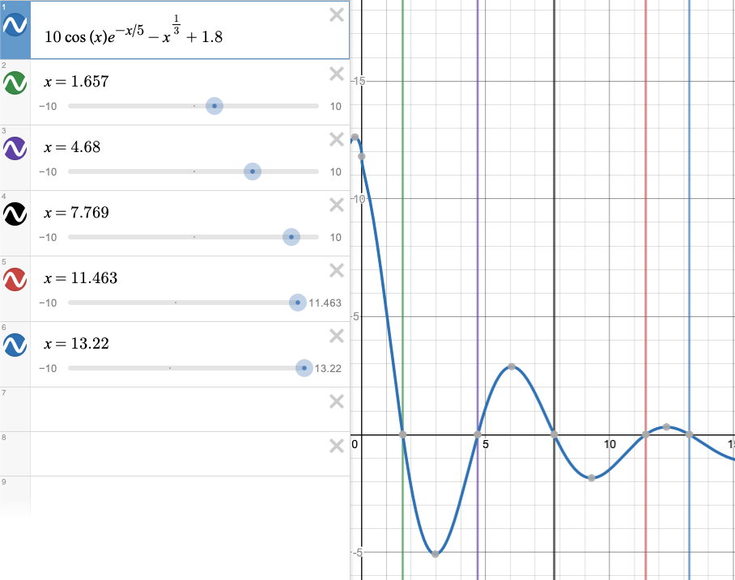

Using the desmos.com graphical calculator I was able to observe 5 positive roots.

After X= 13.22, the F(x)=10cos(x)e-x/5+1.8 is less than F(x)= x1/3 so I am sure there are no more roots.

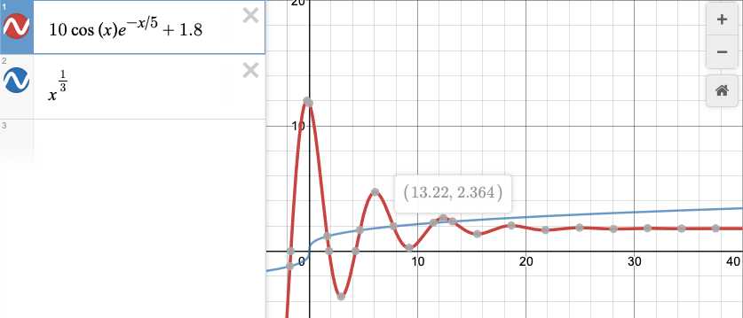

* 1. Newton-Raphson method. All roots must be determined with the absolute approximate error no larger than **Ea = 10-6** .

First let’s find the first derivative: F’(x)= −10e−x/5 sin(x)−2e−x/5cos(x)−1/(3x2/3)

Then used Eq 6.6 Xi+1=Xi-F(Xi)/F’(Xi).

I had to start a little over X=0 because F’(x) is undefined at X=0. I repeated the iteration till

|  |  |  |  |  |  |  |
| --- | --- | --- | --- | --- | --- | --- |
| Iteration | X | Et % |  | Iteration | X | Et % |
| 0 | 0.1 |  |  | 0 | 7 |  |
| 1 | 2.5772013 | 96.1198219 |  | 1 | 7.8382867 | 10.6947701 |
| 2 | 0.6230311 | -313.6553534 |  | 2 | 7.7676537 | -0.9093234 |
| 3 | 1.7754425 | 64.9084064 |  | 3 | 7.7685105 | 0.0110301 |
| 4 | 1.6526772 | -7.4282644 |  | 4 | 7.7685106 | 0.0000014 |
| 5 | 1.6567977 | 0.2487039 |  | 5 | 7.7685106 | 0.0000000 |
| 6 | 1.6568019 | 0.0002491 |  | 0 | 11.0000000 |  |
| 7 | 1.6568019 | 0.0000000 |  | 1 | 11.4030949 | 3.5349607 |
| 0 | 4.0000000 |  |  | 2 | 11.4608009 | 0.5035073 |
| 1 | 4.7066020 | 15.0129974 |  | 3 | 11.4625208 | 0.0150046 |
| 2 | 4.6797800 | -0.5731471 |  | 4 | 11.4625224 | 0.0000137 |
| 3 | 4.6799202 | 0.0029948 |  | 5 | 11.4625224 | 0.0000000 |
| 4 | 4.6799202 | 0.0000001 |  | 0 | 13.0000000 |  |
|  |  |  |  | 1 | 13.2418525 | 1.8264253 |
|  |  |  |  | 2 | 13.2197112 | -0.1674871 |
|  |  |  |  | 3 | 13.2195671 | -0.0010902 |
|  |  |  |  | 4 | 13.2195671 | 0.0000000 |

I found 5 roots X= 1.656801, 4.679920, 7.7685106, 11.462522 and 13.219567 with the absolute approximate error no larger than **Ea = 10-6**.

1. Using Gaussian elimination with partial pivoting solve linear algebraic equations

x1 + x2 – x3 = -3

6x1 + 2x2 + 2x3 = 2

-3x1 + 4x2 + x3 = 1

Also, compute the value of determinant.

|  |  |  |  |  |
| --- | --- | --- | --- | --- |
|  | X1 | X2 | X3 | EQUAL |
| A | 1 | 1 | -1 | -3 |
| B | 6 | 2 | 2 | 2 |
| C | -3 | 4 | 1 | 1 |
|  |  |  |  |  |
|  | X1 | X2 | X3 | EQUAL |
| A | 1 | 1 | -1 | -3 |
| B | 0 | -4 | 8 | 20 |
| C | 0 | 7 | -2 | -8 |
|  |  |  |  |  |
|  | X1 | X2 | X3 | EQUAL |
| A | 1 | 1 | -1 | -3 |
| B | 0 | -4 | 8 | 20 |
| C | 0 | 0 | 12 | 27 |
|  |  |  |  |  |
| VARIABLE | VALUE |  |  |  |
| X1 | -0.25 |  |  |  |
| X2 | -0.5 |  |  |  |
| X3 | 2.25 |  |  |  |

Code is in excel file submitted with this document.